

UK COLORECTAL ROBOTIC SURGERY CONFERENCE AND CADAVERIC HANDS ON DISSECTION COURSE

7-8 May 2019

NEWCASTLE SURGICAL TRAINING CENTRE

Newcastle Surgical Training Centre

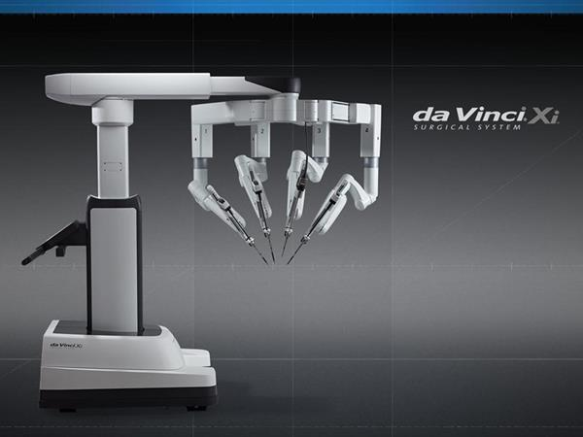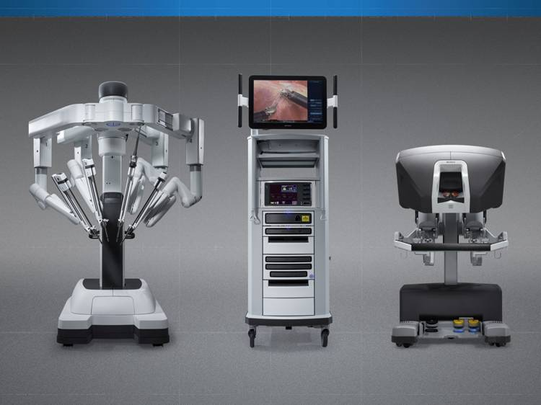

CPD Pending

**THE VERY LATEST TECHNOLOGIES FOR MINIMALLY INVASIVE SURGERY FOR ROBOTIC TRAINING**

**G**

**LATEST TECHNOLOGIES FOR MINIMALLY INVASIVE SURGERY**

**CRYSTAL CLEAR 3D HD**

**REVOLUTIONARY ANATOMICAL ACCESS**

***See the latest technology on the market today....***

Lorraine Waugh, Newcastle Surgical Training Centre

Freeman Hospital, Newcastle upon Tyne

Tel: (44) 191 24 48913 [Email:lorraine.waugh@nuth.nhs.uk](mailto:lorraine.waugh@nuth.nhs.uk)

**SPECIAL FEATURES OF THE COURSE**

[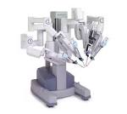](http://www.google.co.uk/url?url=http://www.intuitivesurgical.com/company/media/images/davinci_si_images.html&rct=j&frm=1&q=&esrc=s&sa=U&ved=0ahUKEwj386WcmIXQAhXEBsAKHScuAQQQwW4IGDAB&usg=AFQjCNEX9FZBWFtJXMFgxmTi3cQvdi2qYA)[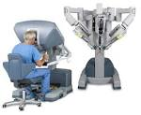](http://www.google.co.uk/url?url=http://intuitivesurgical.com/company/media/images/singlesite.html&rct=j&frm=1&q=&esrc=s&sa=U&ved=0ahUKEwiKwIWQmYXQAhWEC8AKHcf9DJ04FBDBbgggMAU&usg=AFQjCNHQBP4qm82CdY5gNhtN75zsgPj65A)

[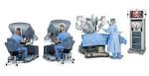](http://www.google.co.uk/url?url=http://robocatz.com/daVinci-surgical.htm&rct=j&frm=1&q=&esrc=s&sa=U&ved=0ahUKEwj386WcmIXQAhXEBsAKHScuAQQQwW4IIDAF&usg=AFQjCNH8DghyBvB3fSprDYHSYgbCs7kJqQ)

[](http://www.google.co.uk/url?url=http://www.davincisurgery.com/da-vinci-surgery/da-vinci-surgical-system/&rct=j&frm=1&q=&esrc=s&sa=U&ved=0ahUKEwj386WcmIXQAhXEBsAKHScuAQQQwW4IFjAA&usg=AFQjCNFIJr-mEFMz9WMsmiDJFVuDqLBdfA)

COURSE OVERVIEW

This course is designed to facilitate the surgeon with didactic and hands on cadaveric training experience. Conducted by a faculty of experienced surgeons, this is an intensive two day course of lectures, debate, exchange and practical hands on experience on Colorectal procedures using an XI

Da Vinci Robot.

**A two day intensive course**

**Number of Dissectors limited to 8**

**DISSECTORS – Will have full access to the Da Vinci Robot with Hands on Procedures and attendance to the Clinical Lectures**

**10 NON DISSECTOR Places only –**

**Non Dissectors will have full access to the Clinical Lectures only**

* **Refreshments included**
* **Course certificate on completion**
* **Course dinner**
* **The course uses fresh frozen cadaveric specimens**

Upon registration, you will be required to complete an online registration and complete some online modules. This will not only register you as a robotic surgeon to be trained, but will also gain you access to procedure videos and clinical data. The modules will take (1-2 hours) this is a pre requisite of the course, you will be required to complete this assessment

**DETAILS ON HOW TO COMPLETE THE ONLINE MODULES WILL BE ISSUED NEARER THE**

**COURSE DATE.**

FACULTY

Mr Peter Coyne – Consultant Surgeon, Newcastle upon Tyne Hospitals NHS Trust

Additional faculty to be confirmed

TARGET AUDIENCE:

Senior Colorectal Trainees & Consultants

Further information

For full details and registration information visit www.nstcsurg.org

Or contact: Louise Sore

Freeman Hospital, Newcastle upon Tyne

Tel: (+44) 191 213 8589

Email: louise.sore@nuth.nhs.uk

COURSE OBJECTIVES

NON DISSECTORS – Clinical Lectures only

* Define the role colorectal robotic surgery in current day colorectal cancer practice
* Appreciate the strengths and weaknesses of the evidence base in this emerging field
* Share best practice on setting up a robotic surgery programme
* Understand the benefits and rationale of offering a colorectal service
* Understand the adjuvant treatment schedule following colorectal surgery

DISSECTORS – Full access to the Da Vinci Robot – with hands on procedures on fresh frozen cadavers and full access to the clinical lectures

* Become familiar with the function and operation of the da Vinci Surgical System
* Appreciate the ergonomics of the da Vinci Surgical system robot and the available robotic instrumentation
* Understand the selection process for patient position, da Vinci surgical team position and robotic surgical approaches
* Learn robotic tissue dissection techniques using monopolar energy

**CPD PENDING**



|  |  |  |
| --- | --- | --- |
| NEWCASTLE SURGICAL TRAINING CENTRE  FREEMAN HOSPITAL | | |
| REGISTRATION FEE: £1200 |  |  |

|  |  |
| --- | --- |
| **Your details** | |
| Surname: | Title: (Mr / Mrs / Miss / Ms ) |
| Forenames: | |
| Job Title: | Department: |
| Hospital Address: |  |
|  | Postcode: |
| Mobile Telephone: | Email: |
| **Further details** | |
| How did you hear about this course? Trust Website Mailing Other | |
|  | |
| Please state any special dietary requirements: | |
| Please state to whom invoices should be addressed (if no alternative contact is given, all invoices  will be directed to the applicant): | |

|  |  |
| --- | --- |
| Declaration | |
| Signed: | Date: |

|  |  |
| --- | --- |
| **Cardholder Name** |  |
| **CARD Number** | ______________________________________________________________________ |
| **Expiration Date** | _____________________________________________________________________ |
| **Valid from date**  **Security number(3 digit number on back of Visa/MasterCard** | ____________________________________________________________________  ­­­­­­­­­­­­­­­­­­­_____________________________________________________________________  ­­­­­­­­­­­­­­­­­­­­­­­­­­­­­­­ |
|  |  |

DA VINCI –COLORECTAL CADAVERIC ROBOTIC COURSE

DATE: 7TH & 8TH MAY 2019

APPLICATION FORM

**Please note:** The course fee will include lunch and refreshments. **Payment can be made via BACS (automatic bank transfer) by credit card, or by cheque, payable to Newcastle upon Tyne Hospitals NHS Trust.** Full details and registration information can be found at [www.nstcsurg.org](http://www.nstcsurg.org) Please note, payment is due at registration to secure your place and attendance on the course is conditional upon advance payment being received. Refunds cannot be given in the event of your cancellation within two weeks of the course date. NSTC cannot accept liability for costs incurred in the event of a course having to be cancelled as a result of circumstances beyond its reasonable control. There is an administration charge of 10% (or £50, whichever is greater) of the total course fee. However, within four weeks prior to the start date of the course, the total course fee will be charged unless in exceptional circumstances at the discretion of the NSTC. While we make every effort to run courses as advertised, we reserve the right to change the timetable and/or the teaching staff without prior notice and to cancel any courses without liability (in which case there will be a full refund of course fees to participant). Note that any consequential losses (e.g. travel or accommodation costs) incurred in such cases remain the responsibility of the booker, and consideration should be made to taking out appropriate travel insurance for any non-refundable costs.

|  |  |
| --- | --- |
| **Your details** | |
| Surname: | Title: (Mr / Mrs / Miss / Ms ) |
| Forenames: | |
| Job Title: | Department: |
| Hospital Address: |  |
|  | Postcode: |
| Mobile Telephone: | Email: |
| **Further details** | |
| How did you hear about this course? Trust Website Mailing Other | |
|  | |
| Please state any special dietary requirements: | |
| Please state to whom invoices should be addressed (if no alternative contact is given, all invoices  will be directed to the applicant): | |

|  |  |
| --- | --- |
| Declaration | |
| Signed: | Date: |

|  |  |
| --- | --- |
| **Cardholder Name** |  |
| **CARD Number** | ______________________________________________________________________ |
| **Expiration Date** | _____________________________________________________________________ |
| **Valid from date**  **Security number(3 digit number on back of Visa/MasterCard** | ____________________________________________________________________  ­­­­­­­­­­­­­­­­­­­_____________________________________________________________________  ­­­­­­­­­­­­­­­­­­­­­­­­­­­­­­­ |
|  |  |

DA VINCI –COLORECTAL CADAVERIC ROBOTIC COURSE

DATE: 7TH & 8TH MAY 2019

APPLICATION FORM