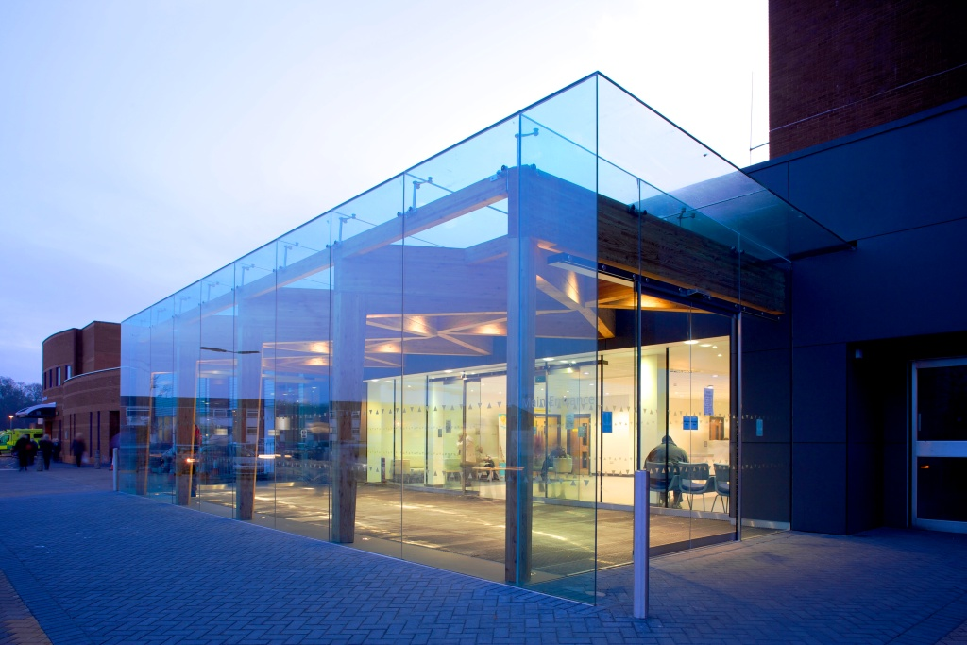
Introduction
Recruitment Briefing
Clinical Fellow in Abdominoplastic Surgery

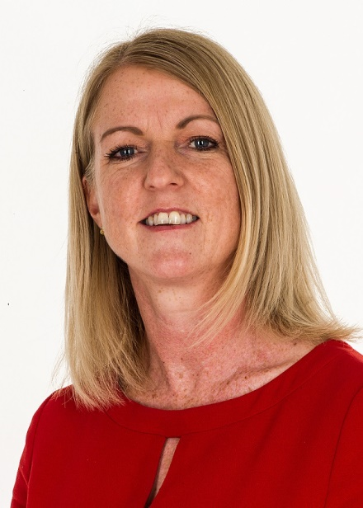

Dear Candidate,

Thank you for your interest in Wirral University Teaching Hospital NHS Foundation Trust (WUTH) and this hugely important position of our new Post CCT Clinical Fellow in Abdominoplastic and Abdominal Wall Reconstruction Surgery.

This organisation is a major employer on the Wirral and we take our role as a partner in the wider health and care economy seriously. We recognise our opportunity and responsibility to improve the future well-being of our population. As an evolving and strengthening senior leadership team we are addressing performance challenges whilst developing a clear strategy to achieve our potential as an organisation and a system.

We are seeking a values-driven Fellow who can build this role and take forward the collaborative clinical and research efforts that were made in the last year.

Wirral really is an enjoyable place to live and to work. I hope you enjoy finding out more about WUTH and its local area of beautiful coastline, recreation and adventure inside this recruitment briefing. Should you wish to talk anything through, please do get in touch.

I look forward to meeting you during the process.

Dr Nicola Stevenson
Executive Medical Director

The local area
Wirral has a stunning coastline and a beautiful countryside, making it a great place to live and work.

It offers 50 miles of rural walking routes, cycle areas and beaches. In fact Wirral has two of Britain’s most famous rivers, the Mersey and the Dee, running along its Eastern and Western coastline.

Excellent housing is available in nearby suburbs and there are a variety of schools. The University of Liverpool, University of Chester and Liverpool John Moores University are also within easy travelling distance.

There is also quality food and drink, including Michelin Star dining and many tea rooms.

The area has an idyllic, serene, landscape and is a delightful location for those who like to unwind with a round of golf as it boasts 14 golf courses.

The cities of Liverpool, Chester and Manchester as well as North Wales are easy reach to and from Wirral with various transport links including motorway, train, bus or ferry. National parks, the Peak District and Lake District are also easily accessible.

There are also excellent transport links to Liverpool John Lennon Airport and Manchester Airport offering both budget and long-haul flights.

Wirral is also an area of rich history with many heritage buildings within its picturesque surroundings.

About WUTH
Wirral University Teaching Hospital serves a population of 40,000. It is one of the biggest and busiest acute NHS trusts on the North West, employing more than 6,000 staff.

Our aim is to deliver the highest quality care for every patient. As a teaching hospital we are renowned as a leader in the region for high quality education and training for a wide range of staff including doctors, nurses and other clinicians.

We are proud of our teaching hospital status and we work closely with the University of Liverpool, University of Chester and Liverpool John Moores University to ensure staff and services reflect the very best clinical practice available.

Our organisation is at the forefront of innovation and a centre of excellence for digital technology. As a Global Digital Exemplar (GDE) we are one of the most digitally enable hospitals in the country, using technology to enhance patient care.

We are one of only 12 NHS acute trusts to achieve the GDE status to develop our digital technology, we call this Digital Wirral.

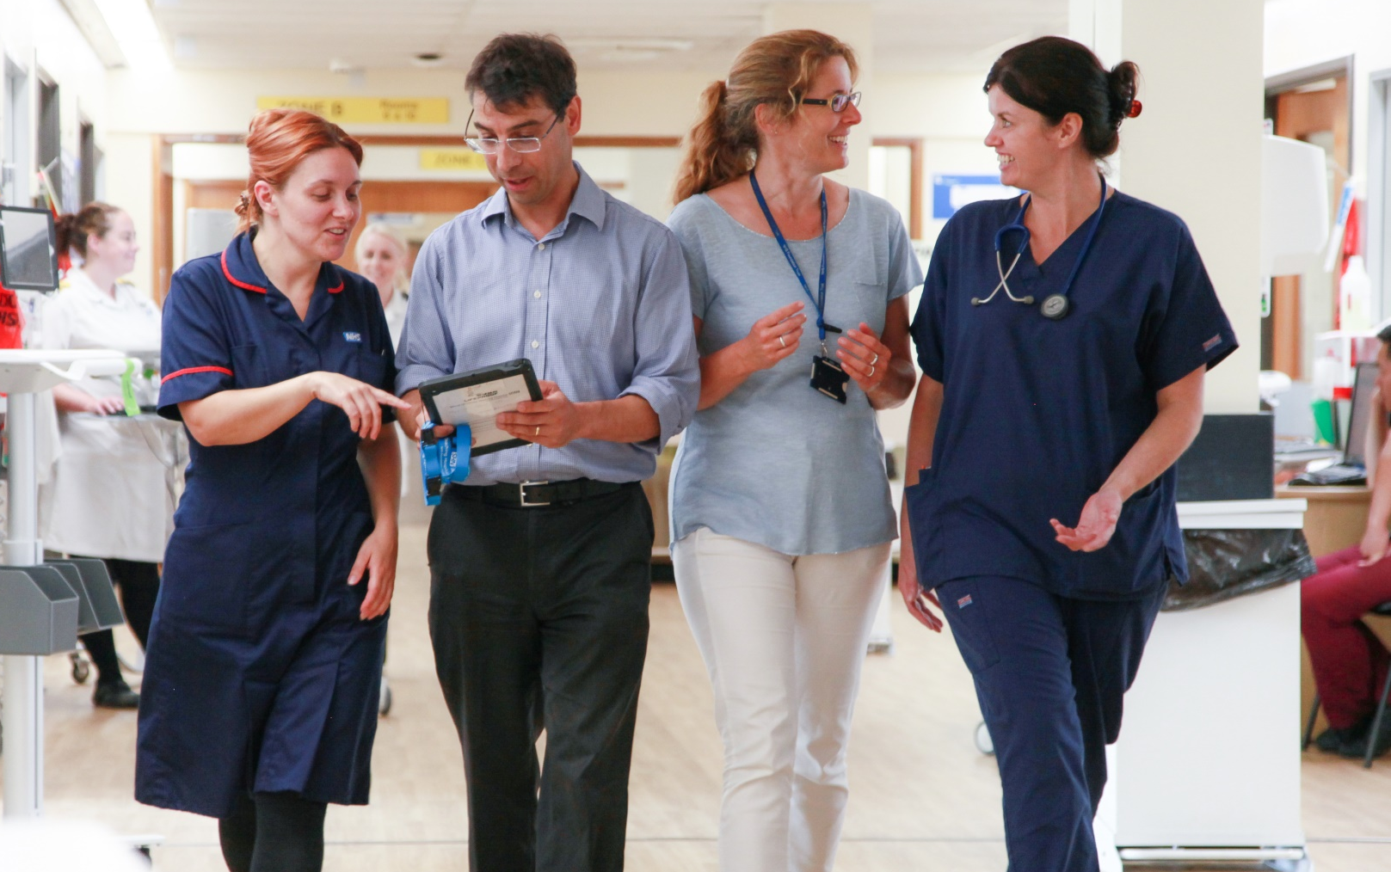
Our WUTH future
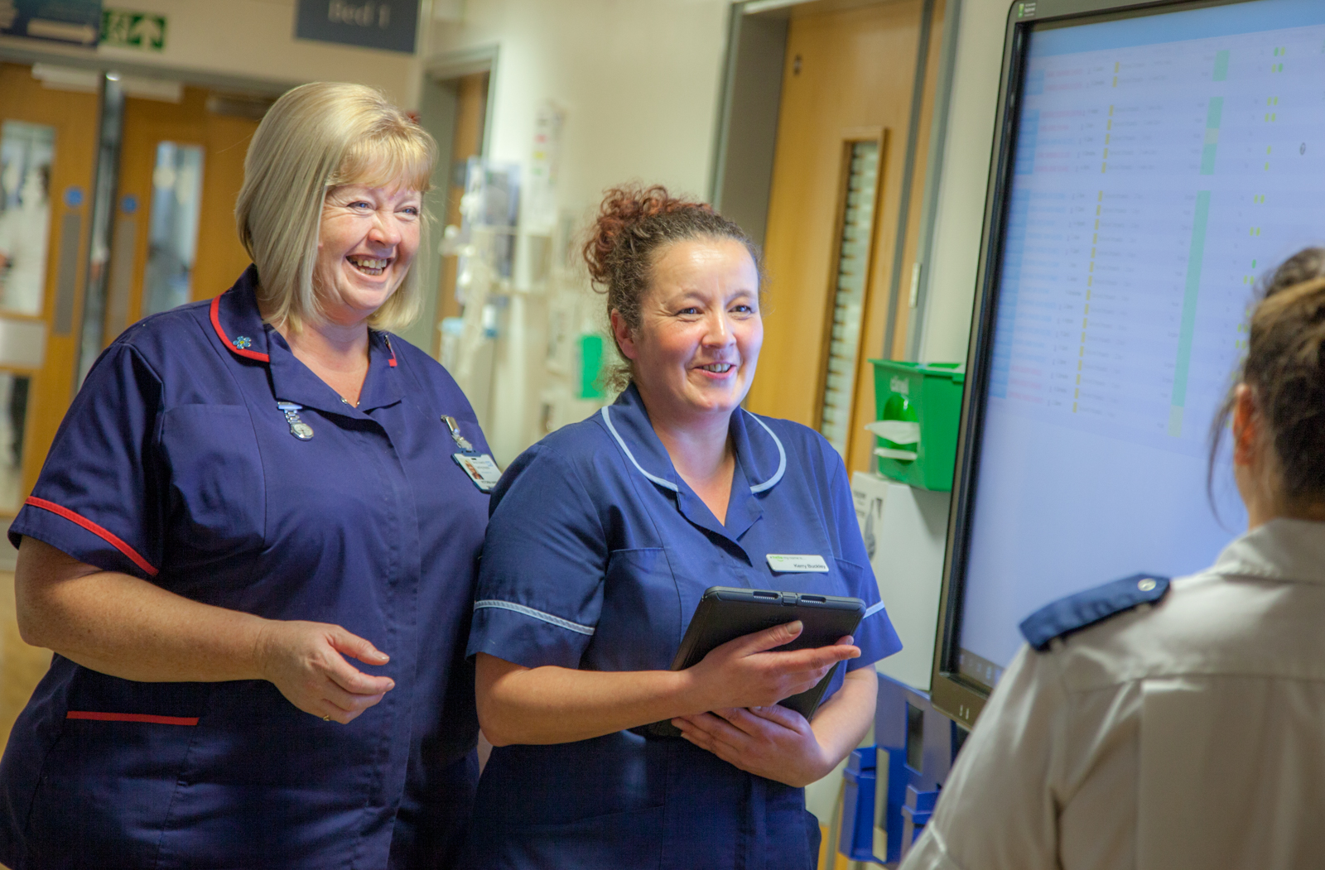
As Wirral’s largest employer, WUTH is the thriving heart of the local community. Comprising Wirral’s only Emergency Department, it is one of the biggest and busiest acute NHS trusts in the North West.

We want to make WUTH a truly great place to both receive care and work and the refresh of our vision and values is a fundamental part of this.

Recent months have seen a period of significant change and challenge, for us as an organisation and across the system and wider NHS.

Despite all of this, colleagues have carried on with great professionalism and have continued to provide good compassionate care to our patients. This has all taken place through what has been one of the hardest winters we have known.

We are well on with our journey of improvement and making a clear commitment to engaging with and investing in the whole of our workforce to support them to lead and improve their services.

There has been a focus on our future road map and what our improvement journey needs to looks like.
WUTH is a great place and we need to be recognised as an organisation that has quality improvement and supporting all staff to deliver the very best care at its heart.

One of the key steps in moving successfully is to ‘bring to life’ our organisational vision and values. We’re currently in the process of updating these, and something we would like you to be a part of.

The opportunity

Job Title | Clinical Fellow in Abdominoplastic Surgery
Division | Surgical Division, General Surgery Directorate
Reporting To | Mr Walsh, Colorectal Consultant

Applications are invited for an exciting opportunity for a peri-CCT or overseas equivalent general surgery trainee to undertake the full time post of Clinical Fellow in Abdominoplastic Surgery within the General Surgery directorate at Wirral University Teaching Hospital and Whiston Hospital Trust.
This is a truly unique opportunity providing general surgery complex hernia experience along with sub specialist abdominal wall reconstruction experience with training from both a general surgical and plastic surgical perspective. The post will prepare the post holder to take up independent practice as a future consultant general surgeon with a subspecialty interest in complex abdominal wall surgery.
The post holder will also have an honorary contract at Whiston Hospital which will allow them to work in the regional plastic surgery unit to gain experience in plastic surgery of the abdominal wall.
This post is available from January 2022 for 12 months. It is are aimed at peri-/post-CCT trainees who have completed their general surgery training.
Applications from suitably qualified international trainees are also welcomed.

The post will commence in February 2023.

Informal enquiries may be made via switchboard 0151 678 5111 x2220 or email
Mr Ciaran Walsh, Consultant Colorectal Surgeon at ciaran.walsh@nhs.net
Or email
Mr Greg Simpson, Consultant Colorectal Surgeon at gregory.simpson4@nhs.net

This Post
This full time post is aimed at peri- / post-CCT general surgery trainees (or overseas equivalent) and is for 6 or 12 months. The post is available for UK surgical trainees wishing to undertake Out Of Programme Experience (OOPE) and is also open to overseas trainees of an appropriate grade.
This post will provide specialist abdominal wall surgical experience from both a general surgical and plastic surgical perspective to prepare the post holder to take up independent practice as a future consultant general surgeon with a subspecialty interest in abdominal wall surgery. Additionally, our centre is building its experience in minimally invasive abdominal wall reconstruction using laparoscopic and robotic platforms and a Fellow will be expected to gain experience in such minimally invasive surgical techniques applied to abdominal wall reconstruction.
The post is unique in having both general and plastic surgery training components. The Fellow will work across the General Surgery directorate at WUTH with involvement in appropriate abdominal wall cases. The placement will predominantly be with Mr Ciaran Walsh and Mr Greg Simpson in General & Colorectal surgery with both elective and emergency commitments. Mr Walsh and Mr Simpson will act as supervisors at the Arrowe Park site. The Fellow will also have an honorary contract in the regional plastic surgery centre in Whiston Hospital under the guidance and supervision of Mr Michael Scott, Consultant General Surgeon and Mr Christian West, Consultant Plastic Surgeon where they will undergo plastic surgery training in abdominal wall surgical techniques. There will be no on call commitment in Whiston Hospital.
The Clinical Fellow will be able to direct their training needs. They will receive supported training in the management of complex and straight forward abdominal wall problems ranging from the most challenging abdominal wall reconstructions performed in a multidisciplinary manner to more straight forward hernias performed by open or laparoscopic technique. Whilst the Fellow will be based in the Colorectal Surgery department they will also have opportunity to take part in elective and emergency abdominal wall procedures carried out by our Upper GI and Emergency General surgeons (EGS) who are also committed to training.
The successful applicant will have the opportunity to develop independent practice. The Department of Coloproctology has active research programmes and encourages participation in audit and on-going professional development opportunities. An Abdominal Wall Reconstruction multidisciplinary meeting has been set up between WUTH and Whiston hospitals. The Fellow will be expected to help develop this cross-site meeting. There will be opportunities for the Fellow to attend AWR surgical workshops during their attachment and it is expected that they will take part in research and audit activities in the department.
Duties of Post:
- Elective Duties will be over 40 hours Monday to Friday
- To take part in elective surgery procedures in general, colorectal and abdominal wall surgery including abdominal wall reconstructions at Arrowe Park Hospital (APH).
- To attend general surgery and abdominal wall specific outpatients at APH
- To perform an independent but supervised hernia surgery list at WUTH.
- To learn abdominal wall ultrasound diagnostic and therapeutic techniques at WUTH
- To learn Ultrasound guided administration of Botox to the abdominal wall.
- To learn a variety of abdominal wall reconstruction adjuncts including Preoperative pneumoperitoneum, intra-operative fascial traction and mesh-mediated fascial traction.
- To learn cross sectional imaging of the abdominal wall
- To attend departmental audit, M&M and training meetings at WUTH.
- To attend a plastic surgery abdominal wall specific outpatient clinic at Whiston hospital
- To attend elective abdominal wall surgery lists at Whiston Hospital.
- To help run the abdominal wall MDT between Whiston and APH
- To support junior surgical trainee colleagues in the colorectal surgery department
- To maintain a prospectively collected AWR database

- Emergency Duties:
- To take part in the 1:12 on call SpR rota for nights but with a view to developing independent practice as a consultant.
- To support junior surgical trainee colleagues.

On call duties are limited to APH, The fellow will take part in the registrar on call rota but will be rostered with senior consultants to facilitate independent practice and minimal disruption to the fellowship elective work timetable whilst at the same time maximising experience in emergency general surgical and abdominal wall problems. EGS surgeons cover the emergency theatres during the day and it is expected that the fellow will support this work in appropriate cases.

Location of Duties
Wirral trust (WUTH) has both an acute (Arrowe Park, APH) and elective (Clatterbridge, CBH) site. Major elective surgery also only occurs on the APH site. Minor or day case procedures will be carried out at CBH and outpatients may be on any of the WUTH sites. Plastic surgery training lists in abdominal wall surgery will take place in the regional plastic surgery centre at Whiston hospital. A day case hernia list will take place at the CBH site.

Theatres
On the Arrowe Park site there are 12 theatres, including a well-equipped dedicated general surgery theatre. A dedicated theatre within the main theatre suite is available throughout the day for emergency surgery. There is a separate daily trauma list. Obstetric and Gynaecology facilities are offered in the Women’s Unit, The Duchess of Westminster Wing, on the Arrowe Park site.
At Clatterbridge Hospital there are 7 Orthopaedic and General Surgery theatres and an endoscopy suite where cystoscopy and biopsies are performed.

General Surgery Directorate team

Colorectal Surgeons:

Mr Darren Smith (Clinical Director General Surgery), Mr Jim Anderson (Clinical lead), Mr Liviu Titu, Mr Ciaran Walsh,Mr Jeremy Wilson, Mr Greg Simpson, Mrs Becca Saunders
6 SpR, 3 SHO and 3 ANPs

Upper Gastrointestinal Surgeons:

Mr Andrew Masters, Professor Conor Magee, Mr Shafiq Javed and Mr Raj Parameswaran

4 SpR, 2 SHO

Emergency Surgeons

Mr Rafik Ishak, Miss Katherine Buckley, Mr Antonio Gallucci, Mr Richard Guy (Clinical Service Lead Emergency General Surgery)

2 SpR, 1 SHO and 5 ANP

